
ICOH 2015-2018 TRIENNIUM

ICOH SCIENTIFIC COMMITTEE 2015-2018
WORK PLAN FORM

Includes Chair and Secretary full contact details.

Includes List of Scientific Committee Members.

Please return your SC Triennium Work Plan no later than November 2015 to:
Vice President Marilyn Fingerhut mfingerhut@cdc.gov

Name of Scientific Committee:

Name of Chairperson: Roel Vermeulen Appointed Year __2015___
Contact Information
(Provide name, email address and full contact information details):
Institute for Risk Assessment Sciences
Utrecht University
PO Box 80178
NL 3508 TD Utrecht
The Netherlands
R.C.H.Vermeulen@uu.nl

Name of Secretary: Neela Guha Appointed Year_____2015_____
Contact Information
(Provide name, email address and full contact information details:
International Agency for Research on Cancer
150 cours Albert Thomas
69008 Lyon, France
guhan@iarc.fr

____2015 November______ Date of submission of Triennial SC Work Plan sent to Vice President Marilyn Fingerhut mfingerhut@cdc.gov

Planned business meetings, conferences, seminars: (provide title, location, and dates, if possible)

25th EPICOH - Epidemiology in Occupation Health Conference (September 5-7, 2016)
http://www.epicoh2016.org/welcome

The 25th EPICOH conference will held in conjunction with X2016 and RHICOH 2016

"Occupational Health, Think Globally, Act Locally"
25th EPICOH is organized by the Epidemiology Committee of ICOH. The scientific program will cover all major topics of current epidemiologic research in occupational health. We have chosen the theme to promote the connection between local research and action with research and action in occupational health at the global level. The programme will include pre/post conference workshops and special care will be taken to promote participation of young researchers.

Chairs, Organizing Committee: Manolis Kogevinas and Elena Ronda
Planned Publications, Guidelines*, Position Papers*, etc.: Provide proposed title, authors, publication vehicle if possible. *(Guidelines and Position Papers must be approved before publication by the ICOH Vice President, Secretary General and President.)

Nothing planned

Means of Communication within Committee: (newsletter-provide name and electronic address), website, mailing list, email, forum etc.)

Teleconferences every 2-3 months with the EPICOH management group. E-mail exchanges with membership and business meetings at EPICOH and ICOH conferences

Planned Scientific Contributions to ICOH 2018: (Be specific: oral scientific sessions from submitted abstracts, specially planned scientific sessions, speakers, abstract reviewers, posters, business meeting, etc.)

- Abstract submission, review and presentations in at least one Occupational Epidemiology Session.
- EPICOH Business Meeting
- Keynote presentation

Cooperation with other Scientific Committees: (Provide Conference title, dates, meeting location, collaborating SCs, and role of each SC. Provide relevant details of any other collaborations with SCs.)

SC Industrial Hygiene
SC Occupational Medicine
SC Reproductive Hazards in the Workplace (RHICOH)

RHICOH will participate in the upcoming EPICOH Conference in Barcelona September 2016.

Planned participation and support to WHO – ILO meetings and or publications: (Provide proposed conference title, dates, meeting location and role of the SC. Provide relevant details of other proposed collaborations with WHO and/or ILO.)

None

Cooperation with non-ICOH organizations: (Provide name of non-ICOH organization, proposed conference title, dates, meeting location and role of the SC. Provide relevant details of collaborations other than conferences.)

ISEE
eXposure-conferences

Assistance of ICOH Vice President: (Please indicate how Vice President Bonnie Rogers can be of assistance to your SC.)

Any other points of relevance:

List of SC Members (full name and email address) or please attach the membership list.
The EPICOH membership list is attached to this email and is available online http://www.epicoh.org/members.htm .

Membership (N=123)

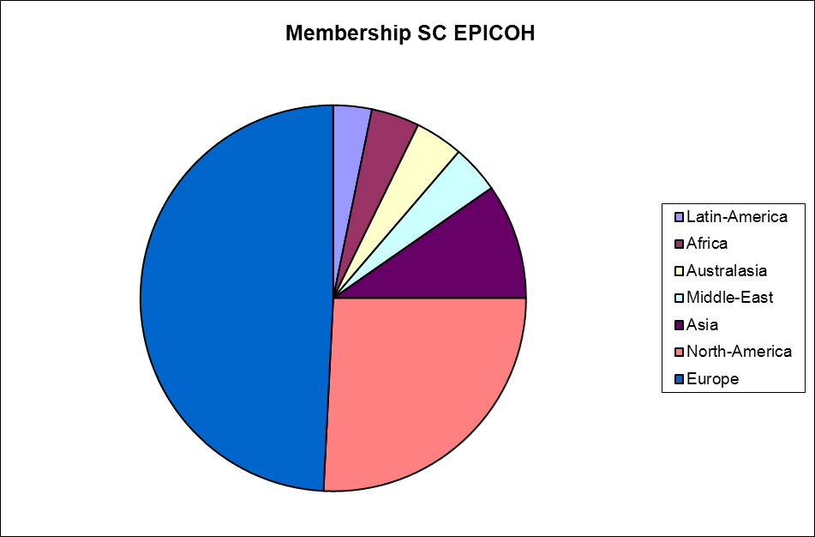

Management Group

Chair
Roel Vermeulen, PhD
Institute for Risk Assessment Sciences
Utrecht University
PO Box 80178
NL 3508 TD Utrecht
The Netherlands
R.C.H.Vermeulen@uu.nl

Secretary
Neela Guha, PhD
International Agency for Research on Cancer
150 cours Albert Thomas
69008 Lyon, France
guhan@iarc.fr
Management Group Members
Laura Beane-Freeman, PhD
National Cancer Institute
Division of Cancer Epidemiology & Genetics, Occupational and Environmental Epidemiology Branch
NCI Shady Grove
Room 6E610
freemala@mail.nih.gov

Prof. Tim Driscoll
The University of Sydney
317B, Edward Ford Building A27 NSW 2006
tim.driscoll@sydney.edu.au
Leon Guo, MD, MPH, PhD
Department of Environmental and Occupational Medicine
National Taiwan University College of Medicine
1, Sec. 1, Jen-Ai Road
Taipei 100, TAIWAN
leonguo@ntu.edu.tw

Prof. Malcolm Sim
Monash University
Alfred Hospital
Commercial Road
Victoria 3004
Melbourne, Australia
Malcolm.Sim@monash.edu

Prof. Leslie Stayner
Professor, University of Illinois at Chicago
971 Sphpi, M/c 923
1603 W. Taylor St
Chicago, IL 60612
lstayner@uic.edu

